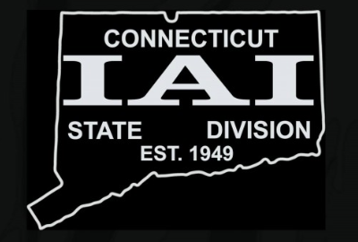
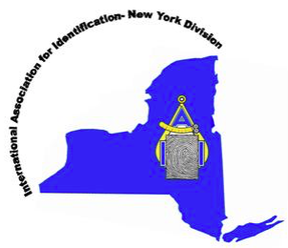
Tri State Divisions (NY, NJ, CT) of
The International Association for Identification
are pleased to announce the

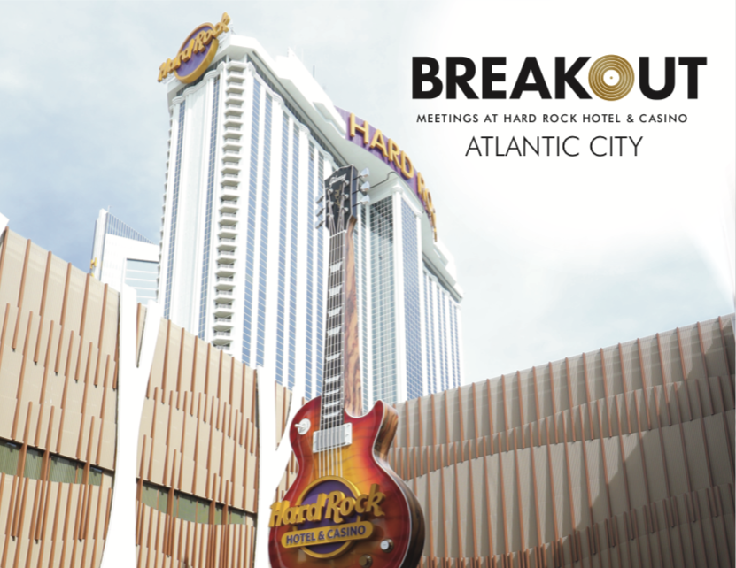

Tri-State Annual Educational Conference
Hard Rock Hotel & Casino
Atlantic City, NJ
October 9, 10, & 11, 2019

REGISTRATION FORM/CONTRACT FOR EXHIBITORS:

PERSON(S) ATTENDING:________________________________________________________
COMPANY NAME: _____________________________ EMAIL:__________________________
ADDRESS:____________________________________________________________________
PHONE #:____________________________ FAX #:___________________________________

COST PER NETWORKING SESSION: $450.00
I am also interested in: ☐Donation of Door Prize ☐Sponsorship of Social Event

DESCRIPTION OF PRODUCTS/SERVICES TO BE EXHIBITED:
________________________________________________________________________________________________________________________________

ALL CHECKS MUST BE PAYABLE TO:
NJIAI
P.O. BOX 423
NEW MILFORD, NJ 07646

EXHIBITOR CONTRACT
We hereby acknowledge receipt of the Vendor Exhibit Contract and agree to the terms above.

COMPANY NAME:______________________________________________________________

SIGNATURE:_______________________________ DATE:_____________________________

PLEASE RETURN CONTRACT FORMS TO:
C/O RYAN MAGNOTTA at the above address

